Fatal Shootings No body Cam?
brett lebouef
4/2/2019
INTRODUCTION The first thing i need to do before i can try to manipulate the data is to read in my data set. The data set i have chosen is an excel file composed by the Washington post. The Washington post compiled data of every fatal shooting in the United States by on duty police officers in 2015 and 2016.
knitr::opts_chunk$set(echo = TRUE)
library(readxl)
washpost <- read_excel("fatal-police-shootings-data.xlsx")
str(washpost)
## Classes 'tbl_df', 'tbl' and 'data.frame': 3960 obs. of 14 variables:
## $ id : num 3 4 5 8 9 11 13 15 16 17 ...
## $ name : chr "Tim Elliot" "Lewis Lee Lembke" "John Paul Quintero" "Matthew Hoffman" ...
## $ date : POSIXct, format: "2015-01-02" "2015-01-02" ...
## $ manner_of_death : chr "shot" "shot" "shot and Tasered" "shot" ...
## $ armed : chr "gun" "gun" "unarmed" "toy weapon" ...
## $ age : num 53 47 23 32 39 18 22 35 34 47 ...
## $ gender : chr "M" "M" "M" "M" ...
## $ race : chr "A" "W" "H" "W" ...
## $ city : chr "Shelton" "Aloha" "Wichita" "San Francisco" ...
## $ state : chr "WA" "OR" "KS" "CA" ...
## $ signs_of_mental_illness: logi TRUE FALSE FALSE TRUE FALSE FALSE ...
## $ threat_level : chr "attack" "attack" "other" "attack" ...
## $ flee : chr "Not fleeing" "Not fleeing" "Not fleeing" "Not fleeing" ...
## $ body_camera : logi FALSE FALSE FALSE FALSE FALSE FALSE ...
library(ggplot2)
VARIABLE DISCRIPTION The variables i have chosen from the data set are race of the person shot, weather the person was armed, and what there threat level was.
BODY_CAMERA This variable shows weather the officers body camera was on or off during the encounter and shooting of the suspect.
table(washpost$body_camera)
##
## FALSE TRUE
## 3527 433
RACE In the variable race you can see that we have data on Asians, Blacks, Hispanics, Native Americans, Other, and White.
table(washpost$race)
##
## A B H N O W
## 61 927 659 62 37 1825
Uni variate
Body Cam
table_body <- prop.table(table(washpost$body_camera))
table_body
##
## FALSE TRUE
## 0.8906566 0.1093434
barplot(table_body, col = c("orange","blue"),main = "Body Cam or No Body Cam", xlab = "Body Cam True or False", ylab = "Count")
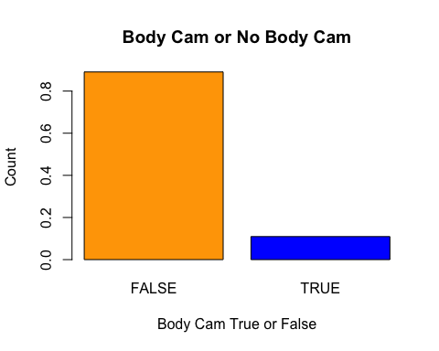 Here we see that almost 90% of all fatal police shootings did not have body cameras on when the shooting took place. This is also shown in the bar plot above where true means the officer has a body camera and false means the officer did not have a body camera or the camera was not on. The bar plot shows that there is a much larger proportion of fatal shootings documented without body cameras which explained the percentages given by the proportion table.
Race
table_race <- table(washpost$race)
table_race
##
## A B H N O W
## 61 927 659 62 37 1825
barplot(table_race, col = c("green","purple"),main = "Race Table", xlab = "Different Types of Race", ylab = "Count")
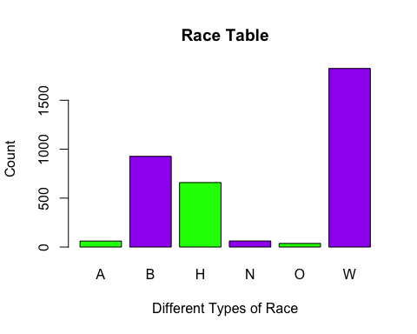 Here we can see the different races of the people who were fatally shot. The table as well as the bar plot, show that the predominant race that the police encountered in the shootings were white. According to the bar plot you can see that the three main races encountered are whites, blacks, and Hispanics. This makes sense because whites make up the largest population in america. Blacks and Hispanics are some of the larger minority groups as well so i think the bar chart gives a good representation of the races that were encountered in the shootings.
Bi variate Body camera vs. Race
ggplot(washpost, aes(x=body_camera, fill=race)) + geom_bar(position = "dodge")
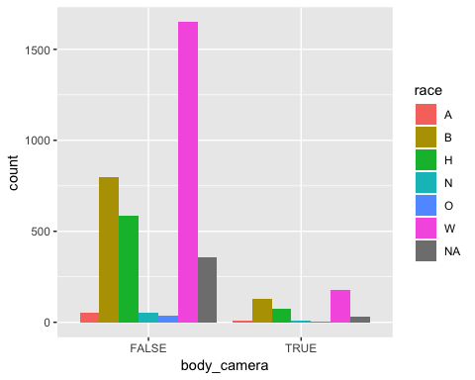 In this graph we can see the amount of each race that was fatally shot with or without a body camera. As seen in the race bar plot the majority of the races in the shootings are whites, blacks, and Hispanics. This explained the numbers in the bi variate bar graph above. Whites have the biggest amount of body camera footage during the times they got shot. Blacks have the second largest amount of body camera footage and the Hispanics have the third largest.
Conclusion All in all I can see that most fatal shootings were not recorded by a body camera which is unsettling. I also saw from my calculations that certain races had larger amounts of fatal shootings then others but that can be explained by the percentage of those races in america. Whites, Hispanics, and blacks are the races that had the largest numbers of people fatally shot by the police but this can be explained by these races having larger populations in america. Lastly I did not seem to find much correlation between body camera footage and race of the individuals involved in the shootings. The body camera footage does not seem to have an unproportionate amount of one race, instead it seems to have evenly distributed numbers that make sense when talking about specific populations of race in america.

