The Effects of Parental HIV
Kelly Clack
4/4/2019
knitr::opts_chunk$set(echo = TRUE)
HIV <- read.delim("/Users/KellyStuff/Documents/MATH_130/Data/PARHIV_081217.txt")
library(dplyr)
##
## Attaching package: 'dplyr'
## The following objects are masked from 'package:stats':
##
## filter, lag
## The following objects are masked from 'package:base':
##
## intersect, setdiff, setequal, union
library(knitr)
library(ggplot2)
library(forcats)

1. The variables I will be exploring.
JOBMO - Mother’s job status. The job status of your parents could be caused by many things, like not recieving a great enough education. Their job status could also be due to the fact that they have HIV and struggle with it.
MONFOOD - Enough money everyday to eat three well-balanced meals if you want to eat them. A child might struggle with getting enough food everyday if they cannot rely on their parents for food.
NGHB8 - If there was drug dealing going on in the neighborhood. If a child lives in a neighborhood with drug activity this can have damaging impacts on the child.

2. A univariate description of each of the variables under consideration.
HIV$MONFOOD <- factor(HIV$MONFOOD, labels = c("No", "Sometimes", "yes"))
table(HIV$MONFOOD, useNA = "always")
##
## No Sometimes yes <NA>
## 12 52 188 0
ggplot(HIV, aes(x = MONFOOD, fill = MONFOOD)) +
geom_bar() +
scale_fill_brewer(palette = "Spectral") +
xlab("Money to Buy Food") +
ggtitle("The Amount of People Who have Money to Buy Three Meals a Day")
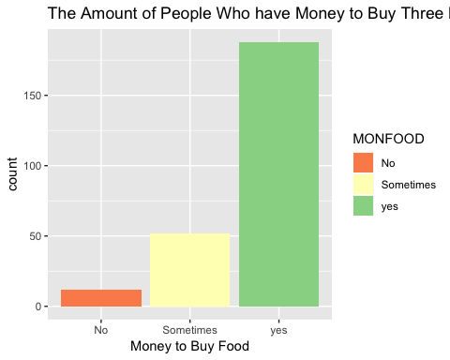
From this graph we can see that most people have the money to buy three balanced meals a day. There was 188 people who said yes, compared to only 12 who said no. With this variable I wanted to see if money was an issue for the majority of people. Although there are still many who seem to be struggling with getting in three meals a day, it is not the majority.
HIV$NGHB8 <- factor(HIV$NGHB8, labels = c("Not a Problem", "Somewhat of a Problem", "Quite a Problem", "Very Serious Problem"))
table(HIV$NGHB8, useNA = "always")
##
## Not a Problem Somewhat of a Problem Quite a Problem
## 63 39 33
## Very Serious Problem <NA>
## 117 0
ggplot(HIV, aes(x = NGHB8, fill = NGHB8)) +
geom_bar(width = .5) +
ggtitle("Drug Dealing in Neighborhood") +
xlab("Current problem for Drug Dealing")
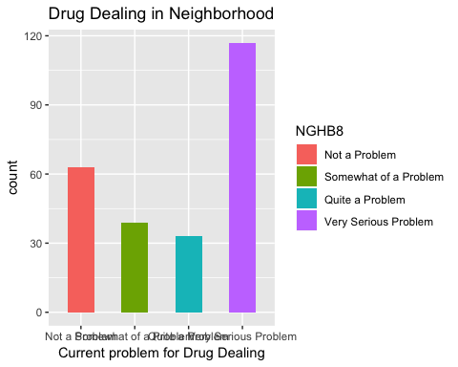
From this graph I can see that most people interviewed seemed to have a very serious problem with drug dealing in their community. With 117 people saying it is a very serious problem, compared to 63 who say it is not a problem at all.
HIV$JOBMO <- factor(HIV$JOBMO, labels = c("Employed", "Unemployed", "Retired/Disabled"))
table(HIV$JOBMO, useNA = "always")
##
## Employed Unemployed Retired/Disabled <NA>
## 29 117 82 24
ggplot(HIV, aes(x = JOBMO, fill = JOBMO)) +
geom_bar() +
ggtitle("Employment of Mother") +
xlab("Employment")
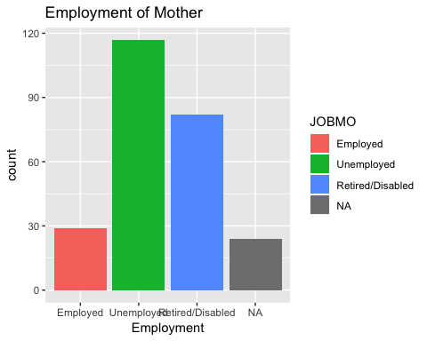
From this graph I can see that most of the mothers are unemployed. With 117 mothers saying they are unemployed, compared to only 29 who say they are employed. There were 24 who declined to mention their employment.

3. A bivariate comparison between two variables of interest.
table(HIV$JOBMO, HIV$MONFOOD)
##
## No Sometimes yes
## Employed 0 4 25
## Unemployed 6 26 85
## Retired/Disabled 5 14 63
ggplot(HIV, aes(x = JOBMO, fill = MONFOOD)) +
geom_bar()
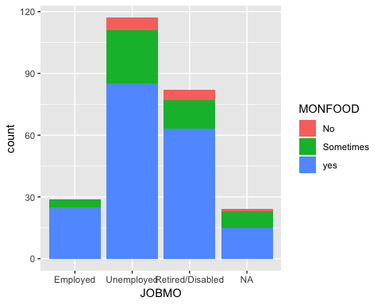
For this graph I wanted to see if there was a relationship between mothers who are unemployed and getting three sufficient meals a day. As we can see The group of mothers who are unemployed have the highest variability on if they are going to get three meals a day or not. Under the unemployed column, 23 of them said that they only sometimes get a good three meals a day. That is compared to the retired/disabled mothers where 14 of them said the only sometimes get three meals a day.

