Fatal Police Shootings in US. 2015
Erik Estrada
April 2, 2019
library(dplyr)
library(ggplot2)
library(readxl)
library(gridExtra)
knitr::opts_chunk$set(echo = TRUE, warning=FALSE, message=FALSE)
washpost <- read_excel("C:/Users/Estra/Desktop/School/Spring 2018-19/math130/Project/fatal-police-shootings-data.xlsx")

Description:
The Washpost data set contains data on the national fatal police shootings that occurred in the US in 2015. It contains variables such as the manner of death, whether the victim was armed, gender, race, and many more. The variables I have chosen to explore are race, age and threat level. The labels are as following A = Asian, B = African-American, H = Hispanic, N = Native American, O = Other, and W = White.

Race of victims fatally shot by Police in 2015
ggplot(washpost, aes(x=race)) + theme_bw() +
geom_bar(aes(y = ..count..)) + ggtitle("Ethnicities of Victims Shot by Police in 2015") +
geom_text(aes(y=..count.. + 50, label=..count..), stat='count', size = 6)
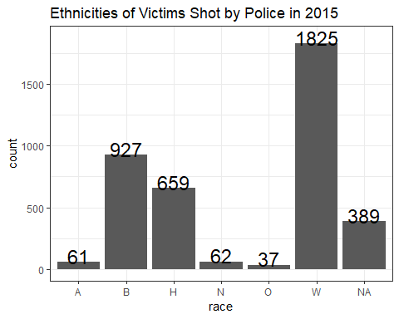
According to the data above in 2015 Caucasian men/women were fatally shot the most by a significant amount with African-American men/women being the second most fatally shot in 2015.

Age of victims fatally shot by Police in 2015
ggplot(washpost, aes(x=age)) + geom_density(col="blue") +
geom_histogram(aes(y=..density..), colour="orange", fill=NA)
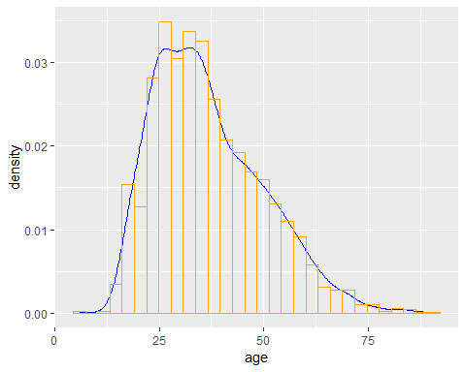
The majority of people fatally shot by police in 2015 were within the age bracket of 25-34 years old. The histogram is skewed right which indicates that the likelihood of being fatally shot rises around 25 years old and steadily stars to decline with age.

Threat level of victims shot by police in 2015
ggplot(washpost, aes(x=threat_level)) + theme_bw() +
geom_bar(aes(y = ..count..)) + ggtitle("Threat Levels of Victims Shot by Police in 2015") +
geom_text(aes(y=..count.. + 50, label=..count..), stat='count', size = 5)
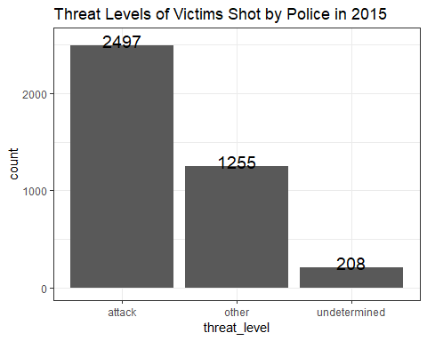
The majority of people fatally shot by police in 2015 were reported to be attacking either the police officer or someone else. At around half of that frequency victims were reported as “other” and with the lowest frequency victims were “undertermined” to be attacking or not.

Bivarite Comparisons

Comparison of age and race
ggplot(washpost, aes(x=race, y=age, fill=race)) +
geom_violin(alpha=.1) +
geom_boxplot(alpha=.5, width=.2)
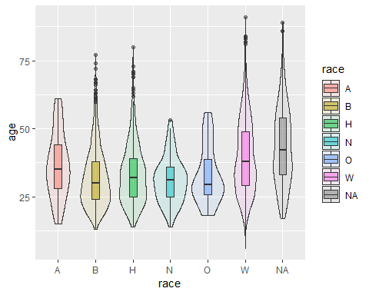
According to the data above each ethnicity has an average of being shot and killed by police at around the same age groups. Caucasion people on average are shot earlier and later in age than other ethnicities, however theyre interquartile range comes later compared to each other ethnicity. African American people are shot and killed in higher density towards the first quartile indicating that they are shot and killed in higher numbers at a young age than any other ethnicity.

Comparison of age and threat level
ggplot(washpost, aes(y=age, x=threat_level, fill=threat_level)) + geom_boxplot() +
scale_fill_discrete(name="Comparison of Age and Threat Level") +
stat_summary(fun.y="mean", geom="point", size=3, pch=17,color="red")
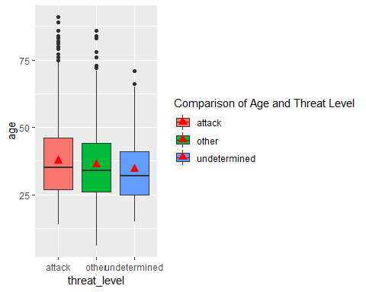
The above boxplot shows that the higher in age the victime was the more likel they were to be violent. This agrees with the interquartile range, mean and median of age all being higher in violent victims, following by other and undetermined having the youngest group of individuals.

Comparison of threat level and race
ggplot(washpost, aes(x=threat_level, fill=race)) + geom_bar(position = "dodge")
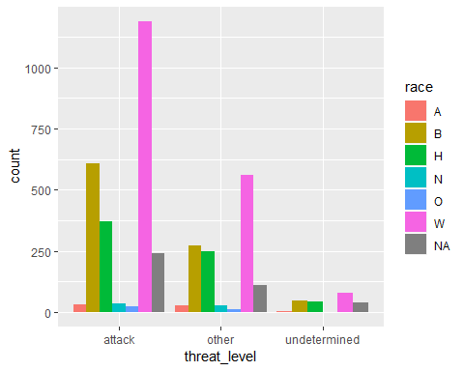
The data above shows that in cases where people were fatally shot by police in 2015 in the US caucasion people had seemed to be the most violent in where they were shot while attacking police officers. Following are African Americans and following them are Hispanics. In cases where the victim was not reported to be attacking, the same trend continues but the gap closes between African Americans and caucasian people. The same trend continues when the situtation was “undetermined” as well as the trend of the gap closing continues as well.

