Biofiltration Data
Gabrielle Wyatt
September 25, 2018
knitr::opts_chunk$set(echo = TRUE)
library(googlesheets); library(dplyr)
gs_auth()
sheet_info <- gs_title("Data Master- Stormwater sampling")
ds_raw <- sheet_info %>% gs_read(skip=1, col_names = TRUE)
source_analysis <- ds_raw[-c(1:10),c(2,5,16,32,33,34)]
This project is a piece of an ongoing EPA P3 grant funded biofiltration research project here at Chico State. We analyze stormwater in the Chico area with particular focus at a Butte College engineered bioswale. Water is analyzed for the presence of heavy metals, excess minerals, hydrocarbons, and general water quality measurements are also performed. Through careful analysis, we have data that shows that the bioswale is effectively removing toxins in the fall, but contributing in the spring. This sink/source observation is most extreme with respect to Chromium, Copper and Nickel. We hypothesize that turbidity might correlate with the findings due to the chemical properties of these metals and the attraction to negatively charged soil particals. For this R project, I would like to compare the turbidity measurements and metal measurements to investigate this hypothesis.
summary(source_analysis)
## Date Sample ID Turbidity Cr (µg/L)
## Length:65 Length:65 Min. : 3.66 Length:65
## Class :character Class :character 1st Qu.: 25.98 Class :character
## Mode :character Mode :character Median : 33.50 Mode :character
## Mean : 40.14
## 3rd Qu.: 49.75
## Max. :131.00
## NA's :11
## Cu (µg/L) Ni (µg/L)
## Min. : 1.30 Length:65
## 1st Qu.: 2.85 Class :character
## Median : 5.10 Mode :character
## Mean : 67.26
## 3rd Qu.: 9.35
## Max. :1690.00
## NA's :14
names(source_analysis) <- c("Date", "IN_OUT_raw", "Turbidity", "Cr", "Cu", "Ni")
summary(source_analysis)
## Date IN_OUT_raw Turbidity Cr
## Length:65 Length:65 Min. : 3.66 Length:65
## Class :character Class :character 1st Qu.: 25.98 Class :character
## Mode :character Mode :character Median : 33.50 Mode :character
## Mean : 40.14
## 3rd Qu.: 49.75
## Max. :131.00
## NA's :11
## Cu Ni
## Min. : 1.30 Length:65
## 1st Qu.: 2.85 Class :character
## Median : 5.10 Mode :character
## Mean : 67.26
## 3rd Qu.: 9.35
## Max. :1690.00
## NA's :14
outlet_rows <- grep("outlet", source_analysis$IN_OUT_raw, ignore.case = TRUE)
inlet_rows <- grep("inlet", source_analysis$IN_OUT_raw, ignore.case = TRUE)
source_analysis$IN_OUT <- "outlet"
source_analysis$IN_OUT[inlet_rows] <- "inlet"
source_analysis$IN_OUT[c(6,16,17,18,29,30,31,34,33,55,58,59,60,57,26,55)] <- NA
print(source_analysis$IN_OUT)
## [1] "inlet" "inlet" "outlet" "inlet" "outlet" NA "outlet"
## [8] "outlet" "outlet" "inlet" "inlet" "inlet" "inlet" "inlet"
## [15] "outlet" NA NA NA "inlet" "inlet" "inlet"
## [22] "inlet" "inlet" "inlet" "inlet" NA "inlet" "inlet"
## [29] NA NA NA "outlet" NA NA "inlet"
## [36] "inlet" "inlet" "inlet" "inlet" "inlet" "inlet" "inlet"
## [43] "inlet" "inlet" "outlet" "inlet" "outlet" "outlet" "inlet"
## [50] "inlet" "inlet" "inlet" "inlet" "outlet" NA "inlet"
## [57] NA NA NA NA "inlet" "inlet" "inlet"
## [64] "inlet" "outlet"
library(ggplot2)
library(zoo)
##
## Attaching package: 'zoo'
## The following objects are masked from 'package:base':
##
## as.Date, as.Date.numeric
ggplot(source_analysis, aes(x = IN_OUT)) + geom_bar()
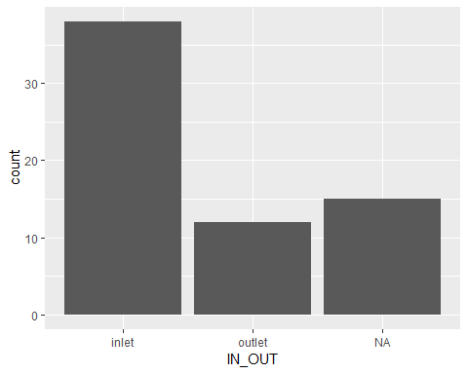
Figure 1: This graph shows the amount of inlets and outlets sampled at the Butte College bioswale.
boxplot(source_analysis$Turbidity, horizontal=TRUE, main="Turbidity Measurements for Stormwater Runoff", xlab="NTU")
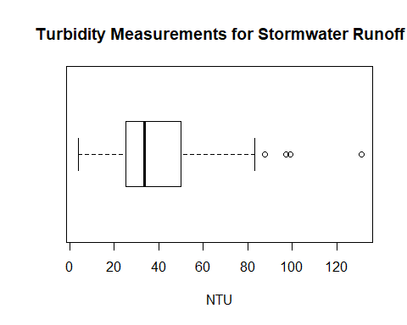
Figure 2: This boxplot shows all of the turbidity measurements for the total bioswale. This includes inlets and outlets.
new_data1 <- source_analysis %>% select(IN_OUT, Turbidity) %>% na.omit()
ggplot(new_data1, aes(y=Turbidity, x=IN_OUT, fill=IN_OUT)) + geom_boxplot()
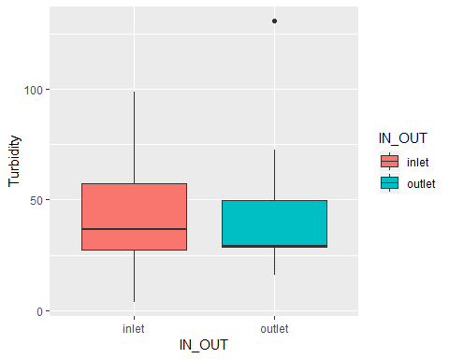
Figure 3: This box plot shows comparative turbidity measurments for inlets and outlets. Although not much different, the mean tubidity is lower for the outlet than the inlet. This means that the bioswale is doing a pretty good job at filtering sediment from the flow of stormwater.
This is an on-going project and I plan on using R to analyze the data I have on the 3 problematic metals and their concentrations at the inlets and the outlets. I would like to compare the values across seasons and also cross anylize with the tubidity data.

